Air flow dags execution not happening

This Sop is for troubleshooting Airflow dags when failed to run or the executions does not have any logs

Steps:-

1. Need to check the Airflow dags function when the iteration started , by that we can know when the job has started

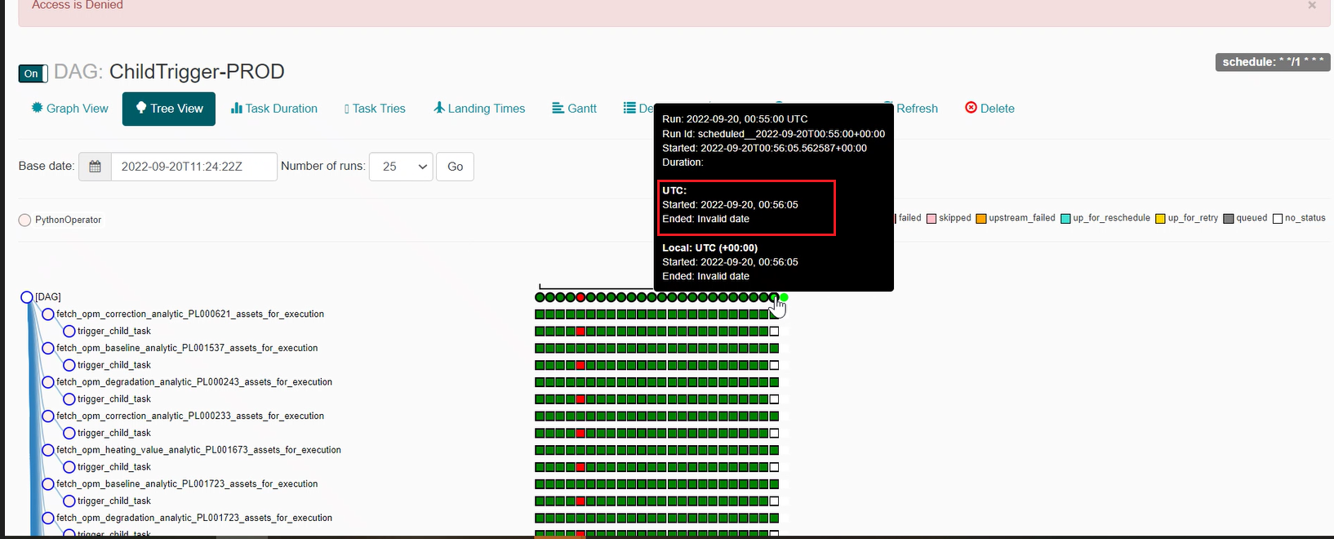

1. When the job has started can been seen here at above screen shot highlighted in red
2. If the job is still running more then expected time , or it is still running with out any logs or jobs are getting failed
3. We need to restart the jobs by marking the iteration as failed or success , mark failure , don’t mark clear .

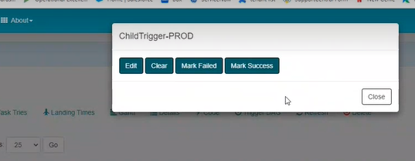

1. Clear will remove the job inducted logs and may skip the iteration ,completely
2. Even if the above process did not worked , We need to check the service’s in server from where Airflow is hosted
3. So for that we need to check Airflow flower or celery to know the ip’s of the hosted server
4. [Common URLs - Power Digital Engineering - Developer Cloud](https://devcloud.swcoe.ge.com/devspace/pages/viewpage.action?spaceKey=XGRDH&title=Common+URLs) this link has the URL’s for Airflow flower or celery
5. What Airflow you need to check that Airflow flower or celery link you need to open using Foxy-proxy

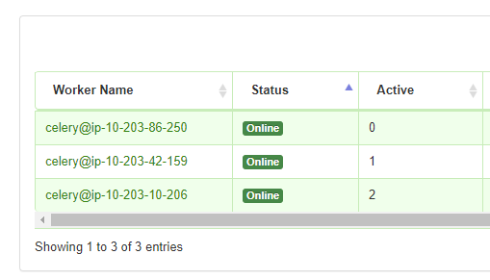

1. There we get the ip’s of worker nodes , copy the ip , login to AWS console paste the ip and search for ec2 instance’s
2. We get the node and next search for the corresponding scheduler of the nodes
3. Login into each instance and check the services

* sudo service airflow-worker status
* sudo service airflow- webserver status
* sudo service airflow-flower status

1. in scheduler

* sudo service airflow-scheduler status

1. we need to restart the services in this scenario

* “ sudo service airflow-scheduler stop” wait for 30 secs and start the service “ sudo service airflow-scheduler start”
* “ sudo service airflow-worker stop” wait for 30 secs and start the service “ sudo service airflow-worker start”
* “ sudo service airflow-webserver stop” wait for 30 secs and start the service “ sudo service airflow-webserver start”
* “ sudo service airflow-flower stop” wait for 30 secs and start the service “ sudo service airflow-flower start”

1. Now check the Dags status That would be running fine